**AIM:**

Construct a Decision Tree for any data set of your choice and classify it.

**DESCRIPTION:**

**Classification & Prediction:**

Classification is the process for finding a model that describes the data values and concepts for the purpose of Prediction.

**Decision Tree:**

 A decision Tree is a classification scheme to generate a tree consisting of root node, internal nodes and external nodes. Root nodes representing the attributes. Internal nodes are also the attributes. External nodes are the classes and each branch represents the values of the attributes

Decision Tree also contains set of rules for a given data set; there are two subsets in Decision Tree. One is a Training data set and second one is a Testing data set. Training data set is previously classified data. Testing data set is newly generated data.

**CONSTRUCTION:**

A tree can be “learned” by splitting the source set into subsets based on an attribute value test. This process is repeated on each derived subset in a recursive manner called recursive partitioning. The recursion is completed when the subset at a node all has the same value of the target variable, or when splitting no longer adds value to the predictions. The construction of decision tree classifier does not require any domain knowledge or parameter setting, and therefore is appropriate for exploratory knowledge discovery. Decision trees can handle high dimensional data. In general decision tree classifier has good accuracy. Decision tree induction is a typical inductive approach to learn knowledge on classification.

**PROCEDURE (WEKA):**

1. Open Start -> Programs -> Weka-3-4 -> Weka-3-4
2. Open **Explorer**.



1. Click on **open file** and select **weather.arff**

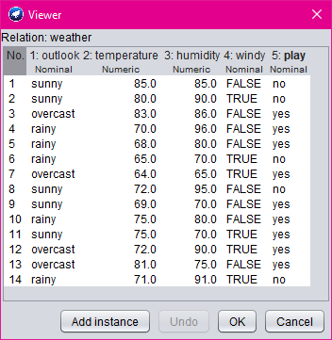

1. Select **Classifier option** on the top of the Menu bar.
2. Select **Choose button** and click on **Tree option**.
3. Click on **J48.**

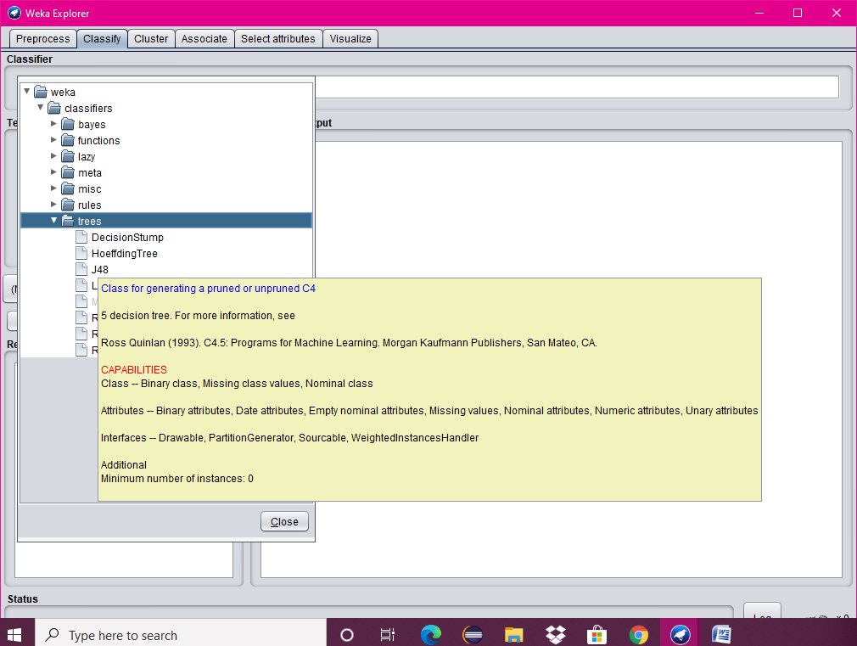

1. Click on **Start button** and output will be displayed on the **right side** of the window.

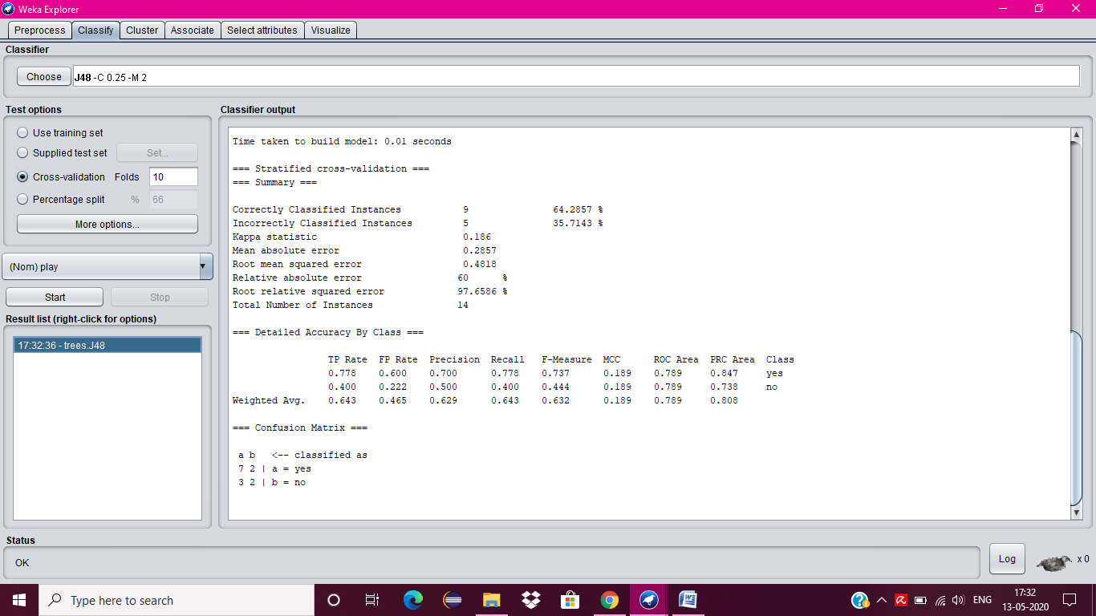

1. Select the **result list** and **right click** on result list and select **Visualize Tree option**.
2. Then **Decision Tree** will be displayed on **new window**.

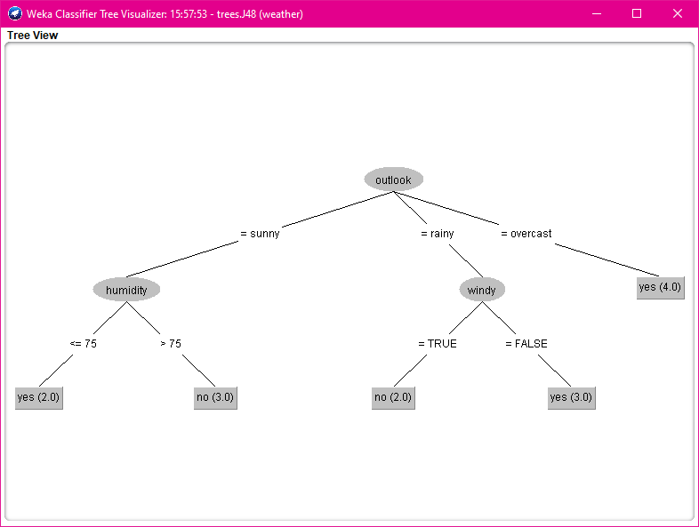

Submitted By-

Kavita Maurya

2016UCO1579